Sam McDowell

7/22/2020

Lab 6-1.1

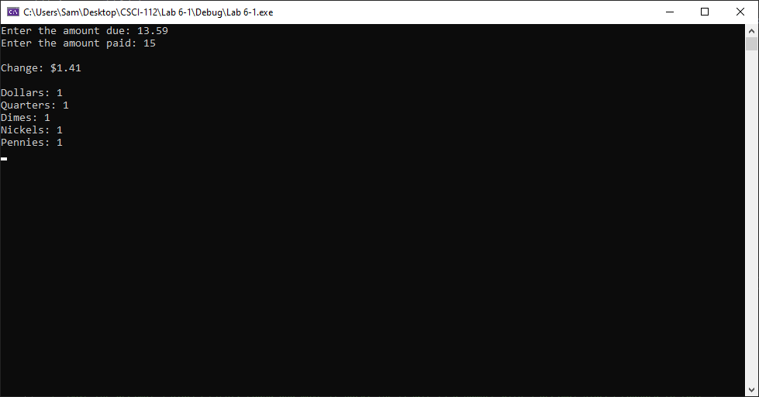

# Transcription:

Enter the amount due: 13.59

Enter the amount paid: 15

Change: $1.41

Dollars: 1

Quarters: 1

Dimes: 1

Nickels: 1

Pennies: 1